Employee Access Center

You can find a link to Employee Access Center on the MISD website, www.monroeisd.us, in the Quicklinks dropdown menu. When you open it, select the MISDfinplus database.

Your login User ID is your employee number (58000xxxx).

Initially your Password is the last 4 digits of your social security number. Please be sure to change your password the first time you log into the system.

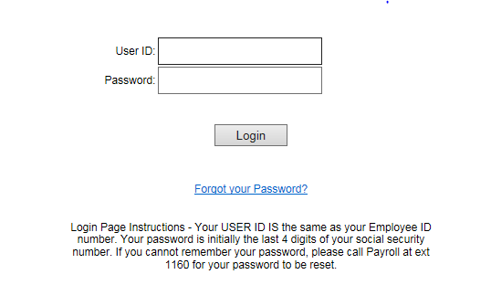
To change your password, select UPDATE ACCOUNT in the upper right corner of the screen.

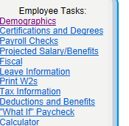
Click on the options in the left panel to view your various personnel screens.

Demographics: Displays your current address and phone number. By selecting UPDATE, you can update your address and phone number. Please add emergency contact information on this screen.

Certification and Degrees: Lists your most current certificate or degree. Contact Human Resources if the information displayed is not correct or current.

Payroll Checks: Lists all of your payroll checks with the most recent listed first. By selecting a pay date, you can view your check stub in pdf form.

Projected Salary/Benefits: Informational. This information is an annualized projection of your salary based on a fiscal year and may not reflect ‘real’ information.

Leave Information: Displays your leave balances. You can display balances as a list or view the year as a calendar. Leave balances may be up to two weeks behind due to the payroll schedule. Be sure to check if your absence day is posted or unposted. Unposted days are not reflected in your balance.

Tax Information: Displays your current tax withholding elections. There are links for federal and state tax forms that can be downloaded and returned to the payroll office for processing.

Deductions and Benefits: Displays your current deductions and year-to-date amounts. It also displays employer paid benefits for retirement and healthcare. When viewing, be sure to note the status of each deduction or benefit.

“What If” Paycheck Calculator: This calculator allows you to make virtual changes to your deductions, tax withholding, hours or wages to see “what if” you made a change.

Please contact Renee Myers 242-5799 ext. 1160 if you have questions.

